QoS Automation Tool

Version 1.0

Contents

What is it? 2

Components 2

Carrier QUEUE-DSCP Mapping 2

Script workflow 3

Inputs 3

Change Module 3

Verification Module 4



**That’s why QoS**

**CABLE**

**ZOOM**

**SKYPE**

**HTTP**

**SQL**

**BACKUP**

# What is it?

It’s a tool to setup new QoS class-map values. It doesn’t change any other parameter like class-map names, neither policy-map (4Q, 5Q, 6Q…) or DSCP mapping.

The script was done using Python.

# Components

* Input module:
  + Routers hostname list
  + Predefined remaining QoS values option list
  + User’s Input Interface:
    - Real time value
    - Remaining Bandwidth Option Selection
* Configuration module
* Verification module
* Output module

# Carrier QUEUE-DSCP Mapping

|  |  |  |
| --- | --- | --- |
| AT&T 4Q | AT&T 6Q | ORANGE 5Q |
| REAL-TIME: | REAL-TIME: | REAL-TIME: |
| D1: | VIDEO: | VIDEO: |
| D2: | D1: | D1: |
| D3: | D2: | D2: |
|  | D3: | D3: |
|  | D4: |  |

AT&T Options example

AT&T 6Q Options:

18421    20% RT, 20/10/60/5/5

18423    20% RT, 20/10/50/15/5

18427    20% RT, 20/10/40/25/5 -> (Recommended by CoP)

# Script Workflow

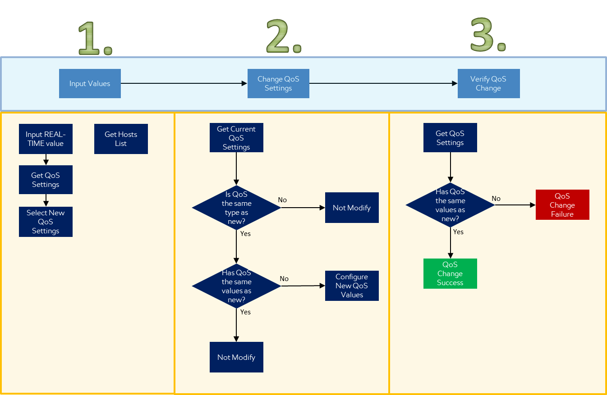

## Inputs

Real-Time parameter is entered manually, it must be a value between 0 and 80.

Remaining QoS values are shown as options where the user has to choose between one of them. If the option needed it’s not shown in the list, then it can be added to the settings list (Not while executing script).

Each remaining QoS values option has to be added following the order as VIDEO/D1/D2/D3/D4. It must have numeric values and the sum of all of them must be =< 100. If there’s a non-existing class-map (i.e. VIDEO) a value of 0 has to be placed. For example, considering a configuration with AT&T 4Q, 0/20/50/20/10 can be used. All these predefined values are preconfigured before running the script, so it’s something to consider only if the needed setting it’s not in the settings list.

## Change Module

If Change Module gets an invalid input like value out of range, or a setup for a policy-map different for the one that target device has (i.e. router has 6Q and input is 4Q type), the change will not be applied and the script will output an error message.

The user can perform the change or get the configuration script for each device.

The script doesn’t analyze if current configuration is correct. It doesn’t remediate any misconfiguration. It only look at the configured class-maps and change their values. If class-map names are not recognized by the tool, it won’t do any change.

## Verification Module

Once configuration is applied, this module checks that the new QoS setting was really placed. Then, it shows to the user if the change was success or a failure. In case that succeed, it saves the new configuration to memory.